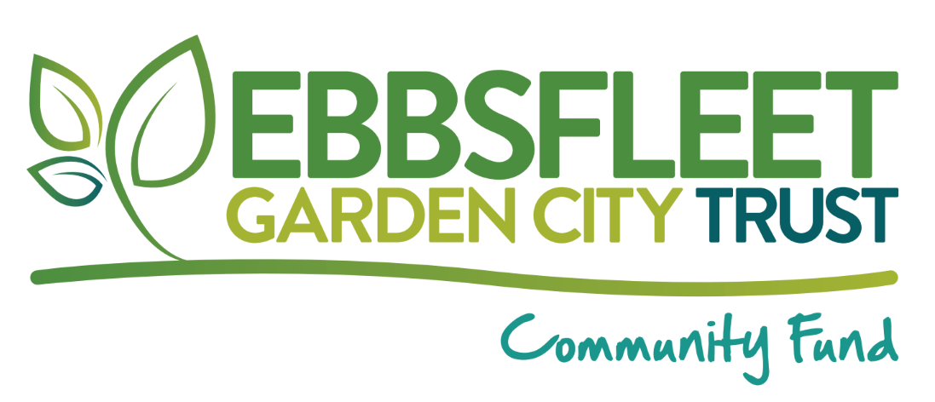

Project Risk Assessment Template
Applicant Name:
Applicant Organisation (if relevant):
Project Name:
Date:

What is a Risk Assessment?
We recognise that things sometimes go wrong when we are organising community activities and events. A risk assessment shows us that you are being proactive about reducing the chance of possible hiccups. It demonstrates that you are wise about protecting people’s safely.
How to Complete This Risk Assessment Template:
In the table provided, list the potential problems that could crop up for your planned activity/event. Tell us how likely each risk is (low, medium, or high chance) of happening and then explain your practical plan to lower the risk of harm.
Example of a risk assessment template:
What could go wrong? (The Risk) | How likely is it? (Low, Med, High) | How serious is it? (Low, Med, High) | What will you do to prevent or manage this risk? | Who will be  responsible?
Example: Heavy rain forces outdoor yoga sessions to be cancelled. | Medium | High | Make it clear on the event flyers that the session will be postponed if it’s raining - to avoid people having a wasted journey. Check weather forecast 24 hours prior to each session and send message on local Whatsapp groups if likely to be cancelled. Reschedule any cancelled sessions to a later date if necessary and communicate new dates via Whatsapp groups. | Jane Doe (Event Lead)
Example: Someone trips over in the community garden and suffers a minor injury | Low | Low | Keep a fully stocked first aid kit in the boot of my car so it can be quickly accessed if needed. | Jane Doe (Event Lead)
Example: A child eats something they are allergic to during the food growing workshop. | Low | High | Parent/carers will be required to supervise their children at all times during the all age food growing workshops. | Community gardening workshop leader (Jack Doe)
Your Project Risk Assessment:
What could go wrong? (The Risk) | How likely is it? (Low, Med, High) | How serious is it? (Low, Med, High) | What will you do to prevent or manage this risk? | Who will be  responsible?
[Add your risk here] | [Low/Med/High] | [Low/Med/High] | [Your action plan] | [Name]
[Add your risk here] | [Low/Med/High] | [Low/Med/High] | [Your action plan] | [Name]
[Add your risk here] | [Low/Med/High] | [Low/Med/High] | [Your action plan] | [Name]
[Add your risk here] | [Low/Med/High] | [Low/Med/High] | [Your action plan] | [Name]
[Add your risk here] | [Low/Med/High] | [Low/Med/High] | [Your action plan] | [Name]
[Add your risk here] | [Low/Med/High] | [Low/Med/High] | [Your action plan] | [Name]
[Add your risk here] | [Low/Med/High] | [Low/Med/High] | [Your action plan] | [Name]

